SRS Document

|  |  |
| --- | --- |
| **Aryan Ahmed** | **F2021105025** |
| **Ambreen** | **F2021105009** |
| **Asmara Shaukat** | **F2021105037** |
| **Hamda Qadeer** | **F2021105035** |

**DenCare Appointment System**

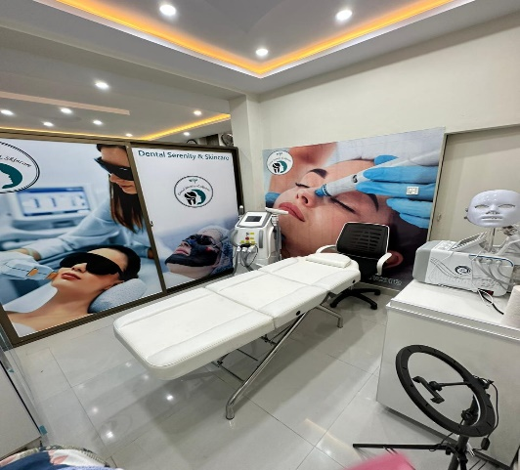

Table of Contents

**1 Introduction** 3

**1.1 Purpose:** 3

**1.2 Document Conventions:** 3

**1.3 Project Scope:** 3

**1.4 References:** 3

**2. Overall Description** 4

**2.1 Product Perspective:** 4

**2.2 User Classes and Characteristics:** 6

**2.3 Operating Environment:** 7

**2.4 Design and Implementation Constraints:** 8

**2.5 Assumptions and Dependencies:** 9

**3. Features:** 10

**3.1 Use Case Descriptions:** 10

**4. Data Requirements** 28

**4.1 Logical data model:** 28

**4.2 Data dictionary:** 30

**4.3 Data acquisition:** 30

**4.4 Data Integrity:** 30

**4.5 Data Retention and Disposal:** 31

**5. External Interface Requirements** 31

**5.1 User Interfaces:** 31

**5.2 Hardware Interfaces:** 32

**5.3 Software Interfaces:** 32

**5.4 Communication Interfaces:** 33

**6. Quality Attributes** 33

**6.1 Security:** 33

**6.2 Performance Requirements:** 34

**6.3 Maintainability:** 34

**6.4 Reliability:** 34

**6.5 Portability:** 34

**6.6 Safety:** 34

**7. Internationalization and localization Requirements:** 35

**8. Other Requirements:** 37

**Appendix A:** 37

# **1 Introduction**

DenCare Appointment System is a software solution designed to facilitate the scheduling and management of appointments between dentist and patients. It streamlines the process of booking appointments. The primary objective of an appointment system is to improve the overall experience of a patient by providing a convenient and organized approach to book appointments. By automating the appointment, it helps to minimize errors, reduce waiting times.

## **1.1 Purpose:**

Theobjective of this document is to present a detailed description of the ‘DenCare Appointment System’. It will explain the purpose and features of the system, the interfaces used in the system, what the system will do and the constraints under which it must operate, and how the system will react to external stimuli. This document is intended for both stakeholders and developers of the system.

## **1.2 Document Conventions:**

The document is composed using Microsoft Word 2010 and has font ‘Times New Roman’. The font size used in this document is 12pt for content and 14pt for headings (bold) with 1.0-line spacing. All pages are numbered that appears on the bottom right corner of every page in the document.

## **1.3 Project Scope:**

The system will be able to provide ease to patients and dentists in a way by managing daily appointments. The system will be designed to maximize the dentist’s productivity by providing a tool to assists in automating the appointment booking process and record keeping process which will be otherwise done manually.

* **Booking Appointment:**

The system should allow patients to schedule appointments with dentists based on their availability. It should provide a user-friendly interface for selecting time slots and receiving booking confirmation.

* **Patient Registration and Management:**

The system should provide functionality for patients to create accounts or register their information, including contact details, medical history, and preferences. It should enable dentists to access and manage patient records, including appointment history and relevant medical information.

## **1.4 References:**

2 documents we have consulted for reference purpose. The links of both the documents are:

* **For Vision and Scope Document:**

https://www.academia.edu/43527772/Vision_and_Scope_document_Hospital_Management_System_

* **For SRS:**

https://www.studocu.com/row/document/comsats-university-islamabad/software-engineering/srs-hospital-managment-system/10336420

# **2. Overall Description**

The ‘DenCare Appointment System is an online platform, from where you can book your appointments from your preferred dentist on a specific day and time of your own choice. Appointment details and total number of appointments are saved in this system. It will be easy for the dentists to keep a keen eye on the monthly profit, monthly checked patients and loss in any case as well. There are two screens provided in this system; one screen is for the patients to take appointment and the other is for the dentists to see appointments made. First the patient and the dentist have to install the app on their devices. They can install the app in windows and iOS device as well. The logo screen will appear once you install it. Two options are available further like create new account and login to already existing account. You can book your appointment by entering the details and selecting services you want to take from the clinic. On booking appointment, the system will give an appointment id or number with total charges for the services and some other information. Payment logs are maintained to keep record of payments made. Patient or dentist can also connect some hardware device like printer to get copy of receipt. Patient can take screenshot of it.

## **2.1 Product Perspective:**

The ‘DenCare Appointment System’ is a self-contained system that manages the appointments of the clinic. The dentists and patients are benefitted from it. Various stakeholders are involved in this system.

**DFD Level 0:**

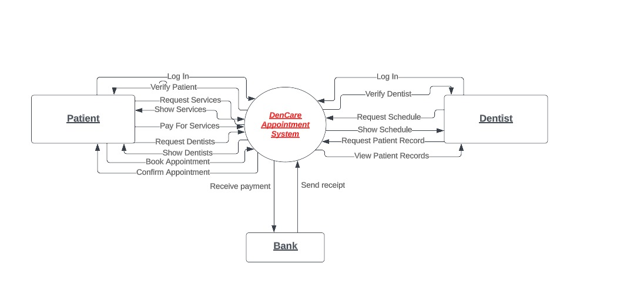

**DFD Level 1:**

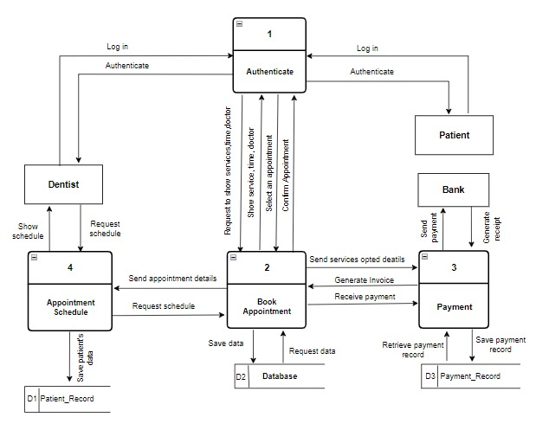

## **2.2 User Classes and Characteristics:**

The system will be used in the ‘DenCare Appointment System’. The patients and dentists will be the main user classes.

**Favored User Class:**

* **Dentist:**

This app is especially designed to benefit the dentists in maintaining their data. It grantees them the necessary access to efficiently manage their appointments. The dentist have the ability to see their appointments schedule, modify existing appointments as needed. They also have access to patient’s information, medical record.

* **Patient:**

This user role is designed for patients, granting them access to necessary functionalities to book their appointments. Patient should be able to view available slots and book appointment with their preferred dentist. Patients will have ability to see their booked appointment and cancel or modify appointment as needed.

**Disfavored User Class:**

* **Hacker:**

The hackers are the disfavored class for the system. Because in the system dentist’s and patient’s data is stored which can’t be breach. So it is necessary to keep the system safe from them.

**Ignored User Class:**

* **Bank:**

In an appointment system designed for a clinic, a bank would typically be considered a disfavored user class since their involvement in appointment management is not directly relevant. Banks are not involved in the scheduling or management of patient appointments.

* **Suppliers:**

Suppliers providing products to the clinic may not require access to the appointment system, as their interactions are primarily related to procurement or inventory management, which can be handled through separate systems or processes.

* **General Public:**

The general public, including individuals who are not patients or dentists, may be irrelevant to the appointment system. They do not require access or privileges within the system.

## **2.3 Operating Environment:**

The system will operate using the hardware, software platform and operating system versions.

* **Servers:**

The appointment system typically runs on servers that host the software and data. This can include physical servers or virtual machines that provide the processing power, storage, and memory required to handle the system's operations.

* **Database Management System (DBMS):**

A DBMS is used to store and manage the appointment system's data, including patient records, appointment schedules, and user information. The choice of DBMS will depend on factors such as scalability, security, and compatibility with the system's requirements.

**Hardware Platform:**

Desktop application, iOS device and windows are hardware platforms for this appointment system. A patient and a dentist as well can access the system using these kind of devices to take appointment and manage appointment.

**OS Versions:**

iOS, windows and android can be used to use this app.

**Geographical Locations of Users:**

In patients point of view, they can take appointment from anywhere in the world. Also the dentist can see it from anywhere.

**Host Websites:**

* **Shared Hosting:**

Shared hosting is a cost-effective option where multiple websites are hosted on a single server. This option is suitable for small clinics with relatively low traffic and simpler website requirements. This will suit best for the clinic appointment system.

* **Managed Hosting:**

Managed hosting is a service provided by a third-party hosting provider that takes care of server management, security, updates, and backups. This option is beneficial for organizations with limited technical expertise or resources to manage their hosting infrastructure. As the clinic is on the starting phase, so they don’t have much staff to manage their technical infrastructure. So, this hosting is choose.

## **2.4 Design and Implementation Constraints:**

* It should be able to handle multiple appointments at a time.
* It should be able to handle multiple payments at a time.
* Guarantee a speed of data display.
* It should log all payments to know what happened in any circumstance.

## **2.5 Assumptions and Dependencies:**

**Assumptions:**

* **Time Availability:**

The software assumes that the dental clinic has designated time slots available for appointments. It assumes that the system is functional any time.

* **Patient Information:**

The software assumes that the patient’s personal information, such as name, contact details, and medical history provided during registration and booking is accurate and up to date.

* **Internet Connection:**

The patient and dentist should have a stable internet connection to use this system. The system might show an error in case of unstable data connection. And in this case the respective person have to re-enter input.

**Dependencies:**

* **Database System:**

The appointment system relies on a database to store and manage patient information, appointment schedules, and other relevant data.

* **Authentication and Access Control:**

The software may depend on authentication system to ensure secure access to the appointment system. This can involve integrating with identity management systems.

# **3. Features:**

## **3.1 Use Case Descriptions:**

|  |  |
| --- | --- |
| ID and Name: | **UC-1 Create Account** |
| Created by: | Hamda Qadeer Created date: 20-5-2023 |
| Primary Actor: | Patient, Dentist |
| Description: | This use case describes the process of creating an account for availing the services of Dental and Skin appointment system. |
| Trigger: | User indicates that they want to create an account. |
| Pre-Conditions: | PRE-1: User identity is authenticated  PRE-2: User passes the robot check |
| Post-Conditions: | POS-1: Verification email/message is sent  POS-2: New account is created to avail services |
| Normal Flow: | 1. User enters correct information to create account 2. Confirmation email or message is sent to initiate further action 3. User verifies the entered information 4. Account is created |
| Alternative Flows: | 1. User fills registration form 2. User enters correct/valid information 3. User is registered and account is created |
| Exceptions: | 1. System gives error and stops the process 2. System gives user option to restart the process (3a) or to exit (4a)   3a. User starts the process again  3b. System starts Normal Flow again  4a. User asks to exit the process  4b. System terminates the process |
| Priority: | High |
| Frequency of Use: | Patients and New Dentists are obligated to create an account for the proper usage of the Dencare Appointment system |
| Business Rules: | BR:1 (Patient have to pay 50% advance payment) |
| Other Information: | Only one account can be created for each patient and dentist |
| Assumptions: | 1. The process of account creation is very user friendly 2. It saves user data and provides data integrity |

|  |  |
| --- | --- |
| ID and Name | **UC-2 Login Account for Appointment**. |
| Created By | Aryan Ahmed Created date: 18-5-2023 |
| Primary Actor | Patient |
| Secondary Actor | Dentist. |
| Description | This use case describes the steps involved in the patient login process for accessing the system. The login functionality allows users to authenticate their identities and gain access to their respective accounts within the system. |
| Trigger | Patient Indicates that he/she want to login his/her account |
| Pre-Condition | PRE-1 Patient and dentist identity has been authenticated.  PRE-2 Patient and dentist must first register his/her account.  PRE-3 Patient and dentist is Authorized to login his/her account.  PRE-4 website/application of dental and skin appointment database is Online. |
| Post-Condition | POST-1 The dentist or patient successfully logs into their account.  POST-2 The dentist or patient can view their appointments.  POST-3 The dentist or patient can manage their appointments, such as rescheduling or cancelling.  POST-4 The dentist or patient can perform other relevant actions within the system  POST-5 Requests are sent to the Website/application. |
| Normal Flow | 1. The dentist user or bank navigates to the system's login page. 2. The system presents the login form, requesting the user to enter their username and password. 3. The dentist or user enters their valid username and password. 4. The user enters their username and password into the respective input fields. 5. The system verifies the entered credentials against the stored data. |
| Alternative flow | 1. If the dentist or patient enters incorrect credentials. The system displays an error message indicating the invalid login attempt. The user is prompted to re-enter their credentials. 2. If the dentist or patient forgets their password, they can click on the "**Forgot Password**" link. The system guides them through the password recovery process. |
| Exception | 1. System display message: Network Down. 2. System ask patient if he want to request another login method. (3a) or to exit (4a)   3a. Patient ask to request another login Method.  3b. System start Normal Flow over.  4a. Patient ask to exit.  4b. System terminate use case. |
| Priority | High |
| Frequency of Use | Multiple times a day, as dentists and patient may need to access the system frequently for their work. |
| Business rule | BR:1 (Patient have to pay 50% advance payment) |
| Other Information | The system must be able to check the authentic Patient. |
| Assumptions | 1. The software application provides a secure and encrypted login mechanism to protect user and dentist credentials. 2. The patient or dentist has already registered an account in the system. 3. The patient or dentist has a stable internet connection to access the software application. |

|  |  |
| --- | --- |
| ID and Name: | **UC-3 View Dentist Detail** |
| Created by: | Hamda Qadeer Created date: 20-5-2023 |
| Primary Actor: | Patient |
| Description: | This use case describes the feature that allows patient to view dentist detail |
| Trigger: | User Indicate that they want to select dentist for appointment so they view their details |
| Preconditions: | PRE-1: User identity is authenticated  PRE-2: Patient and dentist are successfully logged into the system |
| Post conditions: | POS-1: System displays the details of requested dentist  POS-2: Patient views the details and selects suitable dentist |
| Normal Flow: | 1. System presents a search by specification or name option for dentists  2. The system retrieves and shows a list of matching dentists  3. The patient selects the suitable dentist from the list  4. Clinic database is online |
| Alternative Flows: | 1. If the search or filter interface does not provide the suitable dentist, the patient may modify the search criteria.  2. If multiple dentists match the desired qualifications, then patient can choose from them |
| Exceptions: | 1.If the patient enters invalid name or specification then system stops process.  2.System shows message Dentist not found, allows patient to re-enter information (3a) or exit the system (4a)  3a. Patient re-enters and searches for dentist  3b. System shows searched dentists list  4a. Patient exits the system  4b. System terminates the process |
| Priority: | High |
| Frequency of Use: | Each registered patient can view dentist details for any appointment |
| Business Rules: | BR:1 (Patient have to pay 50% advance payment) |
| Other Information: | The dentist details are viewed when selecting an appointment |
| Assumptions: | 1. The medical software system is properly installed, configured, and accessible to the patient and dentist 2. Dentist record are stored and fully secured 3. System provides an intuitive user interface for searching dentist details |

|  |  |
| --- | --- |
| ID and Name | **UC-4 Request for booking an Appointment.** |
| Created By | Aryan Ahmed Created date: 18-5-2023 |
| Primary Actor | Patient |
| Secondary Actor | Dentist, Bank. |
| Description | The patient specifies the appointment by Entering the date. The patient requests an appointment with a specific dentist, and the dentist confirms the availability and schedules the appointment. |
| Trigger | Patient Indicates that he/she wants to book an Appointment. |
| Pre-Condition | PRE-1 Patient identity has been authenticated.  PRE-2 Patient is Authorized to booking an Appointment.  PRE-3 Clinic database is Online. |
| Post-Condition | POST-1 The appointment is successfully scheduled and recorded in the system.  POST-2 Both the patient and the dentist receive confirmation of the appointment.  POST-3 The patient's upcoming appointments list is updated with the newly scheduled appointment.  POST- 4 Request is sent to the Website/Application. |
| Normal Flow | 1. The patient provides the preferred date and time for the appointment. 2. The system checks the dentist's availability for the specified date. 3. If the dentist is available, the system displays the available time slots. 4. The patient selects an available time slot. 5. The system confirms the appointment and updates the dentist's schedule |
| Alternative flow | 1. If the dentist is not available for the specified date. 2. The system displays alternative available time slots for the patient to choose from. 3. The patient selects an alternative time slot, or cancels the appointment. |
| Exception | 1. If the patient encounters any technical issues during the appointment booking process. 2. The patient can contact the software support team for assistance. (3a) or to exit (4a)   3a. Patient ask to request for support team.  3b. System start Normal Flow over.  4a. User ask to exit.  4b. System terminate use case. |
| Priority | High. |
| Frequency of Use | Approximately 1 time per day by each patient. |
| Business rule | BR:1 (Patient have to pay 50% advance payment) |
| Other Information | The appointment booking feature may include additional functionalities, such as rescheduling or cancelling appointments, depending on the requirements of the software application. |
| Assumptions | 1. The patient and dentist profiles, including contact information, are accurately stored in the system. 2. The software application has a reliable scheduling mechanism to handle appointment conflicts and avoid double booking. |

|  |  |
| --- | --- |
| ID and Name: | **UC-5 Search Available Appointment** |
| Created by: | Hamda Qadeer Created date: 21-5-2023 |
| Primary Actor: | Patient Secondary Actor: Dentist |
| Description: | This Use case describes the process in which the patient searches for available appointment. |
| Trigger: | User Indicates that he/she wants to search appointment |
| Pre-conditions: | PRE-1 User identity has been authenticated.  PRE-2 User is Authorized to search appointment.  PRE-3 The dentist and user must be registered and logged into the system.  PRE-4 Clinic database is Online. |
| Post-conditions: | POS-1 The available appointments are shown  POS-2 User selects the suitable appointment  POS-3 The user receives a confirmation or cancellation notification  POS-4 The dentist's schedule is updated accordingly. |
| Normal Flow: | 1. User specifies the appointment by Entering the date.  2. System list the available dentists and their time slots.  3. The user selects a dentist and a preferred time slot.  4. The system verifies the availability of the selected time slot.  5. The system updates the dentist's schedule and notifies the user of the successful/ unsuccessful appointment booking. |
| Alternative Flows: | 1. If the user selects a time slot that is already booked, the system notifies the user and prompts them to select another available time slot 2. If the dentist's schedule changes or becomes unavailable after the user selects a time slot but before confirmation, the system notifies the user and prompts them to select another available time slot. 3. If the dentist cancels an already scheduled appointment, the system notifies the user and updates the dentist's schedule accordingly. |
| Exceptions: | 1. System display message: No appointment for this time.  2. If the user or dentist account is suspended or deactivated, the system denies access and show the message of “Customer Support”.  3. System ask User if he want to request for another appointment. (3a) or to exit (4a)  4a. User ask to request another appointment.  4b. System start Normal Flow over.  5a. User ask to exit.  5b. System terminate use case. |
| Priority: | Medium |
| Frequency of Use: | User requires to search for available appointment |
| Business Rules: | BR:1 (Patient have to pay 50% advance payment) |
| Other Information: | The system may include additional features such as reminders, notifications, and the ability to view or modify existing appointments |
| Assumptions: | 1. The system has access to the dentist's schedule and can determine their availability.  2. The user has a basic understanding of how to navigate the system and select suitable time slots.  3. The user has a stable internet connection to access the appointment management system. |

|  |  |
| --- | --- |
| ID and Name: | **UC-5.1 Search by date** |
| Created by: | Hamda Qadeer Created date: 21-5-2023 |
| Primary Actor: | Patient Secondary Actor: Dentist |
| Description: | This use case describes the searching of available appointments by user,  specifically, by date |
| Trigger: | User indicates that he wants to search for appointment by date |
| Preconditions: | PRE-1 Patient identity has been authenticated.  PRE-2 Patient is Authorized to search.  PRE-3 Clinic database is Online. |
| Post conditions: | POS-1 The available appointments are shown  POS-2 Patient chooses suitable appointment on specific date |
| Normal Flow: | 1. User specifies the appointment by Entering the date.  2. System list the available dentists and their time slots.  3. The user selects a dentist and a preferred time slot.  4. The system verifies the availability of the selected time slot.  5. The system updates the dentist's schedule and notifies the user of the successful/ unsuccessful appointment booking. |
| Alternative Flows: | 1. User searches appointment by dentist’s name  2. System displays available time slots for User  3. User selects suitable appointment of the desired dentist |
| Exceptions: | 1. System display message: No appointment for this date.  2. If the user or dentist account is suspended or deactivated, the system denies access and show the message of “Customer Support”.  3. System ask User if he want to search for another appointment. (3a) or to exit (4a)  4a. User searches for another appointment.  4b. System start Normal Flow over.  5a. User ask to exit.  5b. System terminate use case. |
| Priority: | Medium |
| Frequency of Use: | User usually searches by date for a quick view of available appointments |
| Business Rules: | BR:1 (Patient have to pay 50% advance payment) |
| Other Information: | The system may include additional features such as reminders, notifications, and the ability to view or modify existing appointments |
| Assumptions: | 1. The system has access to the dentist's schedule and can determine their availability.  2. The user has a basic understanding of how to navigate the system and select suitable time slots.  3. The user has a stable internet connection to access the appointment management system. |

|  |  |
| --- | --- |
| ID and Name | **UC-6 Request for Managing appointment** |
| Created By | Aryan Ahmed Created date: 18-5-2023 |
| Primary Actor | Patient |
| Secondary Actor | Dentist. |
| Description | The patient specifies the appointment by Entering the date. The system either offers the patient can managing appointment from the dentist or website/application. |
| Trigger | User Indicates that he/she wants to manage appointment. |
| Pre-Condition | PRE-1 patient identity has been authenticated.  PRE-2 patients must First book an appointment.  PRE-3 patients are Authorized to manage appointment.  PRE-4 The dentist and user must be registered and logged into the system.  PRE-5 Clinic database is Online. |
| Post-Condition | POS-1 The appointment is successfully scheduled or cancelled.  POS-2 The dentist's schedule is updated accordingly.  POS-3 The patient receives a confirmation or cancellation notification |
| Normal Flow | 1. patient specifies the appointment by Entering the date. 2. System list the available dentists and their time slots. 3. The patient selects a dentist and a preferred time slot. 4. The system verifies the availability of the selected time slot. 5. The system updates the dentist's schedule and notifies the user of the successful/ unsuccessful appointment booking. 6. System give dentist the option to view the history of appointment. 7. System store all the information about managing appointment and user. |
| Alternative flow | 1. If the patient selects a time slot that is already booked, the system notifies the patient and prompts them to select another available time slot. 2. If the dentist's schedule changes or becomes unavailable after the patient selects a time slot but before confirmation, the system notifies the patient and prompts them to select another available time slot. 3. If the dentist cancels an already scheduled appointment, the system notifies the patient and updates the dentist's schedule accordingly. |
| Exception | 1. System display message: No appointmentfor this time. 2. If the patient or dentist account is suspended or deactivated, the system denies access and show the message of “Customer Support”. 3. System ask patient if he want to request for another appointment. (3a) or to exit (4a)   4a. Patient ask to request another appointment.  4b. System start Normal Flow over.  5a. Patient ask to exit.  5b. System terminate use case. |
| Priority | Medium. |
| Frequency of Use | Patient can manage appointment for number of times. |
| Business rule | BR:1 (Patient have to pay 50% advance payment) |
| Other Information | 1. The managing appointment use case is part of a larger system that includes other functionalities related to medical services and patient management. 2. The system may include additional features such as reminders, notifications, and the ability to view or modify existing appointments |
| Assumptions | 1. The system has access to the dentist's schedule and can determine their availability. 2. The patient has a basic understanding of how to navigate the system and select suitable time slots. 3. The patient has a stable internet connection to access the appointment management system. |

|  |  |
| --- | --- |
| ID and Name | **UC-6.1 Cancel Appointment.** |
| Created By | Aryan Ahmed Created date: 18-5-2023 |
| Primary Actor | Patient |
| Secondary Actor | Dentist. |
| Description | This use case describes the process of cancelling an appointment in the context of a software system for managing dentist-patient appointments. The primary actor, the Patient, initiates the cancellation request, while the secondary actor, the Dentist, may be notified of the cancellation. The system updates the appointment status and sends relevant notifications to ensure all parties are informed about the cancellation. |
| Trigger | Patient Indicates that he/she wants to cancel Appointment. |
| Pre-Condition | PRE-1 Patient identity has been authenticated.  PRE-2 Patient is Authorized to cancel.  PRE-3 The Patient must have an existing appointment  PRE-3 Clinic database is Online. |
| Post-Condition | POST-1 The appointment is successfully cancelled.  POST-2 The Patient is notified of the cancellation.  POST-3 The Dentist is notified of the cancellation.  POST-4 The Dentist's schedule is updated to reflect the cancellation.. |
| Normal Flow | 1. The Patient selects the appointment they want to cancel. 2. The system prompts the Patient to confirm the cancellation. 3. The Patient confirms the cancellation. 4. The system updates the appointment status to "Cancelled." 5. The system sends a cancellation notification to the Patient. 6. The system sends a cancellation notification to the Dentist |
| Alternative flow | 1. if the Patient does not want to cancel the appointment, they can choose to go back to the appointment view page. |
| Exception | 1. The appointment has already passed, and it cannot be cancelled. 2. The appointment cannot be cancelled within a certain time frame before the scheduled time (e.g., within 12 hours of the appointment). (3a) or to exit (4a)   3a. System start Normal Flow over.  4a. Patient ask to exit.  4b. System terminate use case. |
| Priority | Medium. |
| Frequency of Use | Approximately 1 time per day by each cancellation. |
| Business rule | BR:1 (Patient have to pay 50% advance payment) |
| Other Information | The system may allow rescheduling the appointment instead of cancelling it in certain cases. |
| Assumptions | 1. The Patient has a registered account in the appointment management system. 2. The system accurately tracks and updates appointment statuses and schedules. 3. The system can reliably send notifications to Patients and Dentists. |

|  |  |
| --- | --- |
| ID and Name: | **UC-7 Request to view Dental Services** |
| Created by: | Hamda Qadeer Created date: 21-5-2023 |
| Primary Actor: | Patient Secondary Actors: Dentist, Bank |
| Description: | The Dental Services use case describes the interactions between a dentist and a user within a software system that provides various dental-related services. The dentist offers consultations and treatments, while the user seeks medical advice and assistance for their dental concerns. |
| Trigger: | User Indicates that he/she wants to manage appointment. |
| Preconditions: | PRE-1 User identity has been authenticated.  PRE-2 User is Authorized to Show Dental Services.  PRE-3 The user has registered an account and logged into the system.  PRE-4 Clinic database is Online. |
| Post conditions: | POS-1 The dentist has provided consultation or treatment to the user.  POS-2 The user has received appropriate guidance or treatment for their dental concern.  POS-3 The user's medical history and treatment details have been recorded in the system.  POS-4 The dentist and user can securely communicate through the software system. |
| Normal Flow: | 1. User specifies the dental service by Entering the name. 2. The software displays a list of available dental care services along with their descriptions and prices. 3. The system displays the dentist's profile, including their credentials and availability. 4. The dentist evaluates the user's dental concern, asks relevant questions, and provides advice or treatment recommendations 5. The dentist may prescribe medication or suggest follow-up consultations if necessary |
| Alternative Flows: | 1. The system offers alternative available dentists for the user to choose from  2. The system provides information on nearby clinics or recommends visiting a local Dentist |
| Exceptions: | 1. System display message: No Dental Service Available.  2. System ask User if he want to request for another dental service. (3a) or to exit (4a)  3a. User requests another dental service.  3b. System starts Normal Flow over.  4a. User exits.  4b. System terminate use case. |
| Priority: | High |
| Frequency of Use: | Multiple times a day, depending on the number of users and availability of dentists |
| Business Rules: | BR:1 (Patient have to pay 50% advance payment) |
| Other Information: | 1. The software system may integrate with external tools for video conferencing, medical record storage, and appointment scheduling.  2. User feedback and ratings may be collected to improve the system's dentist recommendations and overall user experience. |
| Assumptions: | 1. The dentist is qualified and licensed to provide medical advice and treatment for dental-related concerns.  2. The system ensures the privacy and security of user data and communication.  3. Users have basic computer literacy and access to devices with an internet connection |

|  |  |
| --- | --- |
| ID and Name | **UC-8 Request for Show Skin Services** |
| Created By | Aryan Ahmed Created date: 18-5-2023 |
| Primary Actor | Patient |
| Secondary Actor | Dentist, Bank. |
| Description | The Skin Services use case describes the interactions between a dentist and a patient within a software system that provides various skin-related services. The dentist offers consultations and treatments, while the patient seeks medical advice and assistance for their skin concerns. |
| Trigger | Patient indicates that he/she wants to manage appointment. |
| Pre-Condition | PRE-1 patient identity has been authenticated.  PRE-2 Patients Authorized to Show Skin Services.  PRE-3 The patient has registered an account and logged into the system.  PRE-4 Clinic database is Online. |
| Post-Condition | POS-1 The dentist has provided consultation or treatment to the user.  POS-2 The patient has received appropriate guidance or treatment for their skin concern.  POS-3 The patient’s medical history and treatment details have been recorded in the system.  POS-4 The dentist and patient can securely communicate through the software system. |
| Normal Flow | 1. Patient specifies the skin service by Entering the name. 2. The software displays a list of available skin care services along with their descriptions and prices. 3. The system displays the dentist's profile, including their credentials and availability. 4. The dentist evaluates the patient’s skin concern, asks relevant questions, and provides advice or treatment recommendations 5. The dentist may prescribe medication or suggest follow-up consultations if necessary |
| Alternative flow | 1. Patient selects a dentist, but the dentist's schedule is unavailable. 2. The system provides information on nearby clinics or recommends visiting a local Dentist |
| Exception | 1. System display message: No Skin ServiceAvailable. 2. System ask User if he want to request for another skin service. (3a) or to exit (4a)   3a. User ask to request another skin service.  3b. System start Normal Flow over.  4a. User ask to exit.  4b. System terminate use case. |
| Priority | High. |
| Frequency of Use | Multiple times a day, depending on the number of users and availability of dentists |
| Business rule | BR:1 (Patient have to pay 50% advance payment) |
| Other Information | 1. The software system may integrate with external tools for video conferencing, medical record storage, and appointment scheduling. 2. Patient feedback and ratings may be collected to improve the system's dentist recommendations and overall user experience. |
| Assumptions | 1. The dentist is qualified and licensed to provide medical advice and treatment for skin-related concerns. 2. The system ensures the privacy and security of user data and communication. 3. Patients have basic computer literacy and access to devices with an internet connection |

|  |  |
| --- | --- |
| ID and Name | **UC-9 Request for payment** |
| Created By | Aryan Ahmed Created date: 18-5-2023 |
| Primary Actor | User |
| Secondary Actor | Dentist, Bank. |
| Description | This use case describes the process of making a payment for medical services. The patient, initiates the payment to the dentist for the services rendered. The payment is processed through the bank, ensuring a secure and efficient transaction. |
| Trigger | User Indicates that he/she wants to payment. |
| Pre-Condition | PRE-1The patient must have a valid account with the bank.  PRE-2The patient must have access to a device with internet connectivity  PRE-3 Clinic database is Online.  PRE-4 Bank database is online. |
| Post-Condition | POS-1 The dentist receives the payment for the services rendered.  POS-2 The patient’s account balance is updated, reflecting the deducted payment amount. |
| Normal Flow | 1. The patient initiates the payment process by selecting the "Make Payment" option in the medical service provider's software system. 2. The patient provides the required payment information and confirms the payment. 3. The system securely transmits the payment request to the bank. 4. The bank verifies the user's account and available funds. 5. The bank notifies the medical service provider's system about the successful payment. |
| Alternative flow | 1. If the patient's account does not have sufficient funds, the bank rejects the payment request, and the user is notified about the insufficient balance. 2. If there is a connection issue between the medical service provider's system and the bank, the system displays an error message and prompts the user to try again later. |
| Exception | 1. If the bank encounters a technical issue during the payment process, it notifies the medical service provider's system about the payment failure. 2. The patient is prompted to try again or use an alternative payment method. (3a) or to exit (4a)   3a. System start Normal Flow over.  4a. User ask to exit.  4b. System terminate use case. |
| Priority | High. |
| Frequency of Use | The frequency of use will depend on the number of medical services provided and the user's payment preferences. |
| Business rule | BR:1 (Patient have to pay 50% advance payment) |
| Other Information | 1. The payment process may involve additional security measures such as two-factor authentication or verification codes, depending on the bank's policies. 2. The payment system may integrate with other financial systems, such as insurance providers or reimbursement systems, if applicable |
| Assumptions | 1. The patient 's bank account information is accurate and up-to-date. 2. The patient has sufficient funds in their bank account to cover the payment amount. 3. The patient has a reliable internet connection to initiate the payment process |

|  |  |
| --- | --- |
| ID and Name | **UC-9.1 Print details of payment**. |
| Created By | Aryan Ahmed Created date: 18-5-2023 |
| Primary Actor | Patient |
| Secondary Actor | Dentist, bank. |
| Description | This use case describes the process of printing the details of a payment made between a dentist, a patient, and a bank. It involves generating a printable document (soft copy) that includes all the relevant information about the payment transaction. |
| Trigger | Patient Indicates that he/she wants to prints a details of payment. |
| Pre-Condition | PRE-1 The dentist must have a valid account with the bank.  PRE-2 The patient must have made a payment to the dentist through the bank.  PRE-3 The payment details must be stored in the system.  PRE-3 Bank database is Online. |
| Post-Condition | POST-1 A printable payment details document is generated and available for printing.  POST-2 The document includes all the necessary information about the payment transaction. |
| Normal Flow | 1. The dentist initiates the printing process from the application or system. 2. The system retrieves the payment details associated with the dentist from the database. 3. The system generates a printable document containing the payment details. 4. The document includes information such as the payment amount, date, patient name, invoice number, and any other relevant information. 5. The system presents the generated document to the dentist. |
| Alternative flow | 1. If there are no payment details available for the dentist, the system displays an error message indicating that no payment records are found. |
| Exception | 1. If the payment details cannot be retrieved from the database, the system displays an error message indicating a database error. 2. Patient can ask the request for customer support (3a) or to exit (4a)   3a. System start Normal Flow over.  4a. Patient ask to exit.  4b. System terminate use case. |
| Priority | Medium. |
| Frequency of Use | Patient can be used frequently by dentists for printing payment details. |
| Business rule | BR:1 (Patient have to pay 50% advance payment). |
| Other Information | 1. The payment details document may be in a PDF or other printable format. 2. The document may contain additional information specific to the dentist's practice, such as clinic name, address, and contact details. 3. The generated document may be saved for future reference or documentation purposes. |
| Assumptions | 1. The dentist and Patient has a valid account with the bank. 2. The patient has made a payment to the dentist through the bank. |

|  |  |
| --- | --- |
| ID and Name | **UC-10 view a patient record** |
| Created By | Aryan Ahmed Created date: 18-5-2023 |
| Primary Actor | Patient. |
| Secondary Actor | Dentist. |
| Description | This use case describes the process of viewing a patient record in a Dencare Appointment system. The primary actor, the dentist, and the secondary actor, the user, are both involved in accessing and reviewing patient information. |
| Trigger | User Indicates that he/she wants to manage appointment. |
| Pre-Condition | PRE-1The dentist or user must be authenticated and logged into the medical software system.  PRE-2 The patient whose record is being viewed must exist in the system.  . |
| Post-Condition | POS-1 The dentist successfully accesses the patient's record.  POS-2 The dentist can review the patient's information, such as medical history, test results, and diagnoses.  POS-3 The dentist can navigate through the patient's record to view different sections or details. |
| Normal Flow | 1. The system presents a search or filter interface to find the desired patient record. 2. The system retrieves and displays a list of matching patient records. 3. The dentist selects the desired patient record from the list. 4. Clinic data base is online. |
| Alternative flow | 1. If the search or filter interface does not provide the desired patient record the dentist may modify the search criteria and repeat the search. 2. If multiple patient records match the search criteria. The dentist can select the correct patient from the list. 3. If the patient record cannot be retrieved or displayed. The dentist may encounter a system error message and should contact technical support. |
| Exception | 1. If the dentist does not have the necessary permissions to view the patient record, they will receive an access denied error message. 2. System ask dentist if he want to request for contact developer. (3a) or to exit (4a)   3a. dentist ask to request contact developer.  3b. System start Normal Flow over.  4a. dentist ask to exit.  4b. System terminate use case. |
| Priority | Medium. |
| Frequency of Use | dentists frequently view patient records as part of their daily tasks. |
| Business rule | BR:1 (Patient have to pay 50% advance payment) |
| Other Information | 1. The use case assumes a single patient record is viewed at a time, but the system may support multi-patient record viewing. |
| Assumptions | 1. The medical software system is properly installed, configured, and accessible to the dentist and user. 2. The patient records are accurately stored and maintained in the system. 3. The system provides an intuitive user interface for searching and displaying patient records. |

|  |  |
| --- | --- |
| ID and Name: | **UC-11 View payment Status** |
| Created by: | Hamda Qadeer Created date: 21-5-2023 |
| Primary Actor: | Dentist |
| Description: | This use case describes the process in which dentist can view the payment status of their patients. |
| Trigger: | User indicates the he/she wants to view payment status |
| Preconditions: | PRE-1 Dentist must have a valid account.  PRE-2 Dentist must have access to a device with internet connectivity  PRE-3 Clinic database is Online. |
| Post conditions: | POS-1 Dentist gets access to patient’s payment status  POS-2 System shows patient payment history as well  POS-3 Dentist prescribes meds/ offers services depending on the payment status |
| Normal Flow: | 1. User initiates display of payment status by selecting “View Payment Status” option in the medical service provider's software system.  2. User gets access to patient’s payment status  3. System shows patient payment history as well  4. User prescribes meds/offers services depending on the payment status |
| Alternative Flows: | 1. User ask for payment receipts  2. Patient delivers the payment receipts  3. User prescribes meds/offers services depending on the payment status |
| Exceptions: | 1. If the clinic encounters a technical issue viewing the payment status, it notifies the medical service provider's system.  2. The user is prompted to try again or use an alternative method. (3a) or to exit (4a)  3a. System start Normal Flow over.  4a. User ask to exit.  4b. System terminate use case. |
| Priority: | High |
| Frequency of Use: | User views payment status of each patient and prescribes meds/offers services depending on the payment status |
| Business Rules: | BR:1 (Patient have to pay 50% advance payment) |
| Other Information: | System also provides the details of patient.  System also displays the payment history of patient. |
| Assumptions: | The user has a reliable internet connection to view payment status |

# **4. Data Requirements**

## **4.1 Logical data model:**

Following Class Diagram visually represents the basic working of the Dencare Appointment system.

It includes the entities that form the system, the relations between them and their functionalities.

* **Use Case Diagram:**

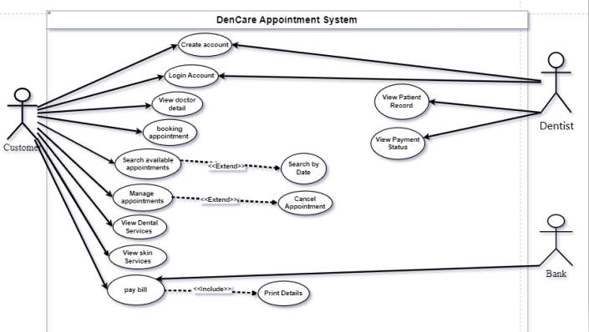

* **Activity Diagram:**

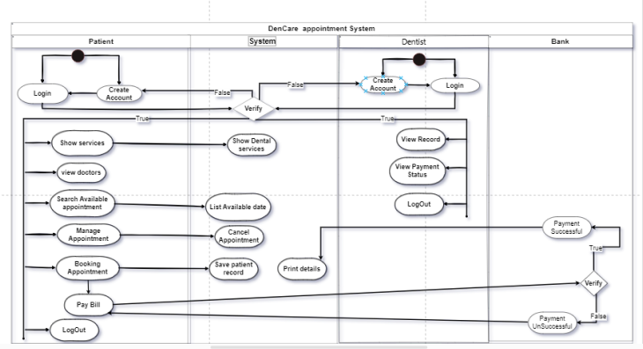

* **Class Diagram:**

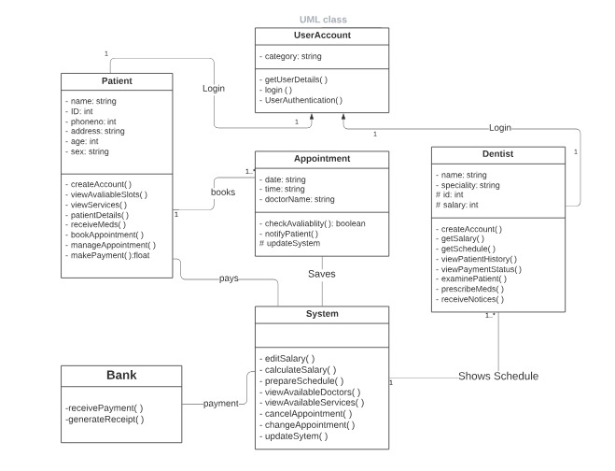

## **4.2 Data dictionary:**

The entities described in the above class diagram include:

* User Account
* Patient
* Dentists
* Appointment
* System

The foremost step for the successful working of the DenCare appointment System for the patients and dentists to set up their accounts to properly interact with the system.

The account the patients set up will enable them to view all the available services and set up timely appointments according to their needs.

In-case of dentists, they will be able to receive their schedules and will have an organized platform for their work. They can even view patients records and their payment status.

The appointments scheduled by the system will be shown to the dentists and patients will be able to manage/re-schedule them.

**Relationships between entities:**

Both Dentist and Patient are able to login into only one account once they set it up for use.

Patient is able to book, manage/re-schedule one or more appointments depending on their needs.

The appointment data is stored by the system consistently, can be viewed later by specific dentist and patient.

The payment data is stored by the system consistently, can be viewed later by dentist.

## **4.3 Data acquisition:**

The data about the appointments is saved and stored by the system database consistently. Apart from this the patient’s records that include his/her medical history as well as payment statues is also saved and stored by the system.

## **4.4 Data Integrity:**

The data about the appointments and patients records as well as dentist’s schedule is very sensitive, therefore, it is not accessible to everyone as it may be tampered or lost. The system provides security to the data by only allowing authorized users to access the data. The system requires passwords and user logins to access data to ensure security of the data stored. This satisfies the users and provides them an easy and secure to use system.

## **4.5 Data Retention and Disposal:**

Data stored is easily accessed by authorized users only. The system will provide a backup system or the data could also be stored in a hard drive consistently. The system will be able to recover the data if gets lost by cloud or hard drives. The stored data is not disposed as it can’t be retrieved later if done so and can go to the wrong hands i.e., misused, etc.

# **5. External Interface Requirements**

## **5.1 User Interfaces:**

**Standard Buttons:**

These are the standard buttons we have used in our application design:

* Back button
* Help button
* Menu button
* Home button
* Profile button

**Keyboard Shortcuts:**

These are the keyboard shortcuts we have used in our application design:

* Ctrl + H (Help)
* Ctrl + S (Save Appointment Draft)
* Ctrl + M (Menu)
* Ctrl + H (Home)
* Ctrl + P (Profile)

**Screen Layout Constraints:**

These are the screen layout constraints we have used in our application design:

* **Font Size:**
  + Headings 32
  + Sub-Headings 28
  + Body 18, 20
* **Fonts:**
  + Headings (Inter, Bold)
  + Sub-headings (Lancelot, Ultra, Inria Serif)
  + Body (Inter)
* **Screen Size:**
  + 390 x 844 pixels
* **Colors:**
  + Background 3B7881
  + Text background 09393D
  + Text Color D1E8E8

**Error Message Display:**

Following are some of the error message displays:

* If there is an issue with someone’s record the system will show an error to check again.
* If a person leaves a column empty, the system pops up an error saying insert a value.
* If a person has given a wrong card number after verification the system will display a message saying enter a valid card ID.

## **5.2 Hardware Interfaces:**

**Format:**

This application is supported by the following formats:

* Any mobile application having android versions that released after October 4th, 2021 (Android 12).
* Any iOS device that supports iOS 14 and onwards.
* Any desktop application having Windows 7 onwards.
* It is supported only by Windows.

**Resources:**

Hardware resources that will be connected to this application include:

* Dell Inspiron N4050
* Android & iOS devices
* HP LaserJet P1102 printer for the printing of receipts and daily appointment schedules.
* Hard drive to store the data.
* HP Scanner 2400 for scanning the prescriptions to keep their records.

## **5.3 Software Interfaces:**

This application is associated with a database on Microsoft SQL Server at the backend that stores all the records of patients and the appointments. It is also associated with bank applications to receive patient payments. If the dentists want to retrieve any previous patient treatment they can do so by the database of the system and its response time should be maximum 10 seconds for the retrieval of data from the database otherwise it should show a pop up message saying, “The system is taking longer than usual for your request, please try again in a few seconds”. Google Calendar API’s are used for the scheduling of appointments.

## **5.4 Communication Interfaces:**

Graphical user interface (GUI) is used as a mode of communication between our application and its users.

**Protocols:**

Following are the protocols that will be used for communication in our application:

* TCP/IP protocol is used for the communication of hardware resources with the application.
* FTP will be used for transferring files into the hard drive and external transfers of data.
* Payment gateways will be used to process online bank payments for security.

**Format:**

* 128-bit or 256-bit data encryption is used to send online payment details.

**Constraints:**

Following are the constraints of our application:

* The bandwidth to be used for the transfer of data in our application is 3 Mbits per second.
* The speed of transfer of data should be 8 seconds per 3 MB file.
* The data capacity of transferring of files should not exceed a limit of 3 MB
* The data to be transferred should be in file format.

# **6. Quality Attributes**

## **6.1 Security:**

**SRS001 Login ID:**

Any person who uses the system should have a Login ID & password.

**SRS002 Access to Files:**

Patients should not be given the access to records that do not concern them.

**SRS003 Modification:**

Only the system owners should be given the right to access and modify data in the database.

**SRS004 Privilege Allowed:**

The patients should only be able to see their own history and records from the system, and should not be granted the permission to access the data that does not concern them.

## **6.2 Performance Requirements:**

**SRS005 Response Time:**

The system shall give response within 3 seconds for the ease of the patients and the dentists.

**SRS006 Capacity:**

The system shall have the capacity to support simultaneous access of more than a hundred people.

**SRS007 User Interface:**

The user-interface screen shall respond within 5 seconds.

## **6.3 Maintainability:**

**SRS008 Back up:**

The system shall provide the capability to back up data daily so that no record is lost and is easily retrievable when needed.

**SRS009 Errors:**

The system shall keep a log on all the errors and notify the admin about it immediately so that it can be fixed in time and avoid any inconvenience.

## **6.4 Reliability:**

**SRS010 Availability:**

The system shall be available all the time.

## **6.5 Portability:**

**SRS011 Compatibility:**

The system shall be compatible with all device types and software running on them.

## **6.6 Safety:**

**SRS012 Malicious Attacks:**

The system shall notify the admin when someone tries to break in the system.

**SRS013 Data Loss:**

The system shall be able to recover the data if it gets lost by some features like retrieve from cloud etc.

**SRS014 Backup:**

The system shall be able to provide a backup system or the data could also be stored in a hard drive every now and then to keep it safe.

# **7. Internationalization and localization Requirements:**

**Currency:**

* The software should support the local currency of Pakistan, which is the Pakistani Rupee (PKR) or (Rs).
* System should handle currency formatting, including decimal separators, currency symbols, and grouping separators according to the local conventions.

**Formatting of Dates, Numbers, Addresses, and Telephone Numbers:**

* Dates should be displayed in the local format, which in Pakistan is usually in the "dd/mm/yyyy" format.
* Numbers should be formatted according to the local conventions, such as using commas as thousand separators and dots as decimal separators.
* Addresses and telephone numbers should follow the local format and structure commonly used in Pakistan.

**Language:**

* The software should support the English language.
* software should handle the proper rendering and display of English text, including support for English fonts and bidirectional text if applicable.
* The software should accommodate national spelling conventions within the English language as used in Pakistan.

**Name Order:**

* The software should allow flexibility in handling given name and family name order based on the local conventions. The usual order is "Given Name" followed by "Family Name."

**Time Zones:**

* The software should support the local time zone of Pakistan, which is Pakistan Standard Time (UTC+5).
* It should accurately handle time zone conversions and adjustments for scheduling and displaying date and time information.

**International Regulations and Laws, Cultural, and Political Issues:**

* The software should comply with relevant international regulations and laws applicable to software usage, data protection, privacy, and other legal considerations.
* It should also account for cultural and political sensitivities specific to Pakistan, such as avoiding content that may be offensive or controversial within the local context.

**Paper Sizes:**

* The software should support the standard paper sizes commonly used in Pakistan, such as A4 and Legal.

**Weights and Measures:**

* The software should use the local system of weights and measures, which is the metric system, in accordance with the standards adopted in Pakistan.

**Electrical Voltages and Plug Shapes:**

* The software should consider the electrical voltages and plug shapes used in Pakistan to ensure compatibility with local hardware and infrastructure.

# **8. Other Requirements:**

* **Legal, Regulatory, or Financial Compliance and Standards:**

The Software should comply with all applicable legal and regulatory requirements related to the

Medical industry in Pakistan. This includes compliance with tax, sensitive information safety, laws, and any other relevant regulations imposed by local authorities.

* **Product Installation, Configuration, Startup, and Shutdown**:

The software should provide clear instructions and guidelines for installing, configuring, starting up, and shutting down the system. This includes specifying hardware and software requirements, installation steps, configuration options, and any prerequisites for the correct operation of the system

* **Logging, Monitoring, and Audit Trail Requirements:**

The software should incorporate logging mechanisms to record important events, errors, and user activities. This will help keep the software safe from any hazards as tracking the activities would help detect and bugs.

To ensure user satisfaction it’s essential to monitor the working of the software consistently. Furthermore, for security and accountability purposes, the system should support an audit trail functionality to maintain a record of user actions, modifications, and transactions.

# **Appendix A:**

**Dencare:** The name of the appointment System software.

**Google Calendar API:** used for the scheduling of appointments.

**Appointment database:** records and stores all the information regarding appointments.

**Appointment schedule:** requested by dentist, viewed for reference and record keeping.

**Payment record**: viewed by dentists to verify the payment of patients.

END